**­­­**

Class 7

**Lecture 27**

**MS Access-**

**Create Table.**

**MS Access**



**Lab Objectives:**

* About Table.
* Editing Existing Table.
* Create new Table.

**Database**

A table is a collection of related data held in a structured format within a database. It consists of fields (columns), and rows.

The relational table is a fundamental relational database concept because tables are the primary form of data storage. Columns form the table’s structure, and rows form the content. Tables allow restrictions for columns (i.e., allowed column data type) but not rows. Every database table must have a unique name. Most relational databases have naming restrictions For example; the name may not contain spaces or be a reserved Keyword such as TABLE or SYSTEM.

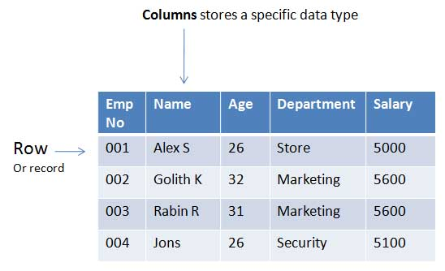

Access 2016 creates a table automatically when you create a blank database. You can customize this table, then create more using the Create tab.

From last class we now have a blank table, having just created a blank database. First, we'll customize that blank table. Then we'll create a new one.

**Customize the Blank Table**

First, we're going to add a field to the existing table. Then we'll rename the existing field.

1. **Select a Data Type for the New Field**

Right-click Click to Add and select Short Text from the combo box. This combo box lists the data types you can assign to a field. Access requires that each field is assigned a data type. In this case, we're telling Access to only allow Short Text in this field. If a user tries to enter a different data type, they will receive an error.

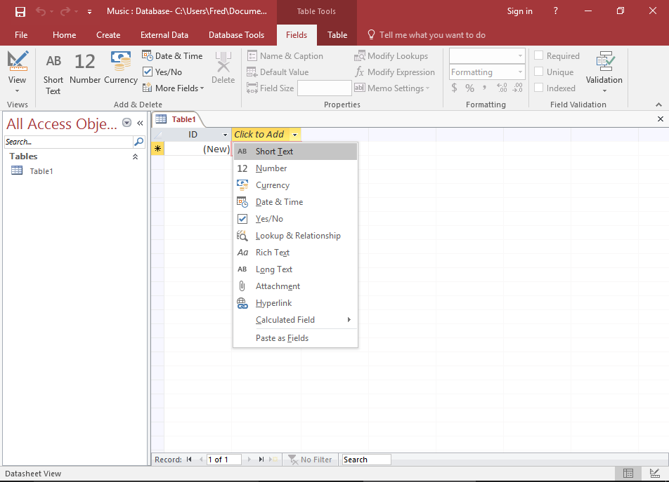

### Name the Field

Once you've selected a data type, the field header will be highlighted with the text Field1 so that you can provide a name for the field. Enter ArtistName as the name of the field.

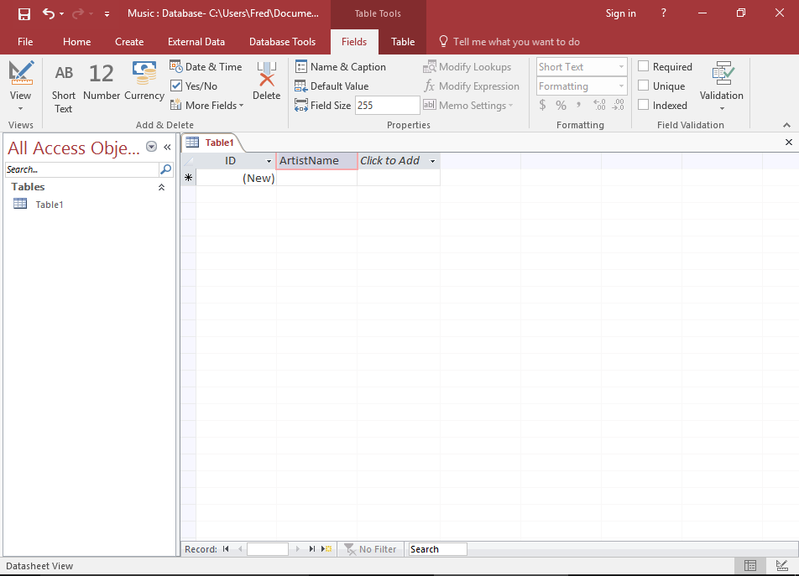

### Rename the First Field

The first field in our table is currently called ID. We'll rename it. Right-click on the ID field header, and select Rename Field. The field will be highlighted for you to rename it. Enter ArtistId.

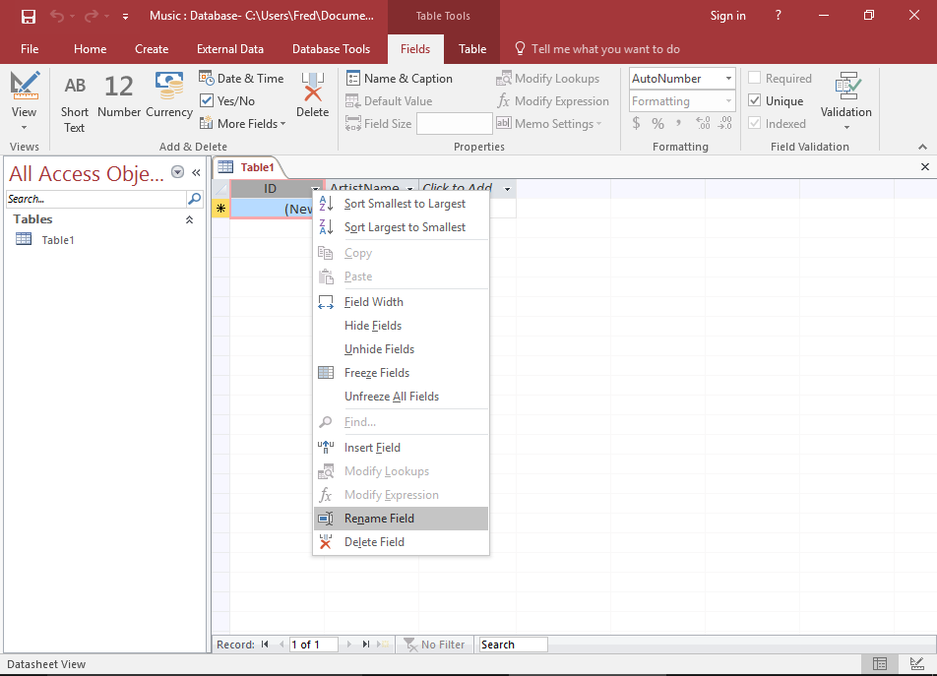

1. **Save the Table**

Right-click on Table1 to save the table. Screenshot of entering a name at the prompt. Enter Artists at the prompt. Right-click on Table1 to save the table. Screenshot of entering a name at the prompt. Enter Artists at the prompt.

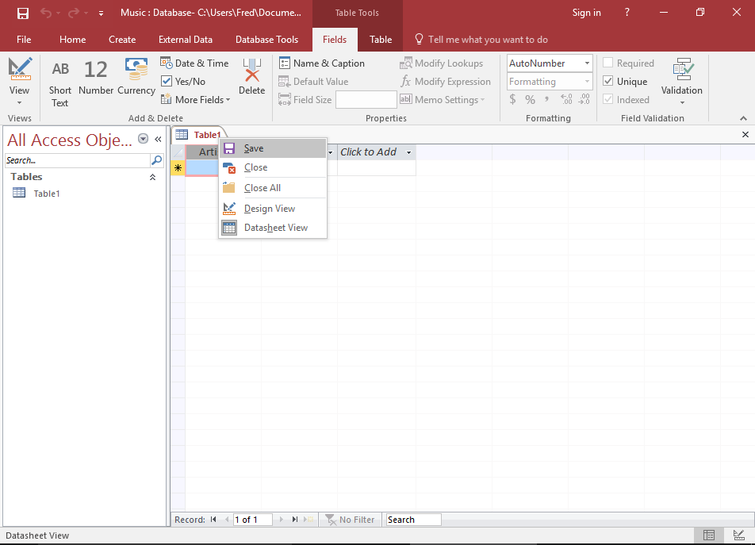

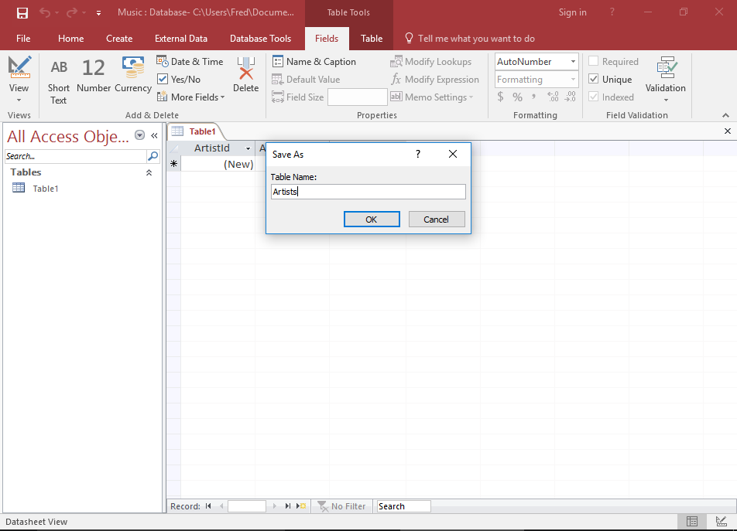

### Your Finished Table

Your database table now contains two fields (ArtistId and ArtistName)

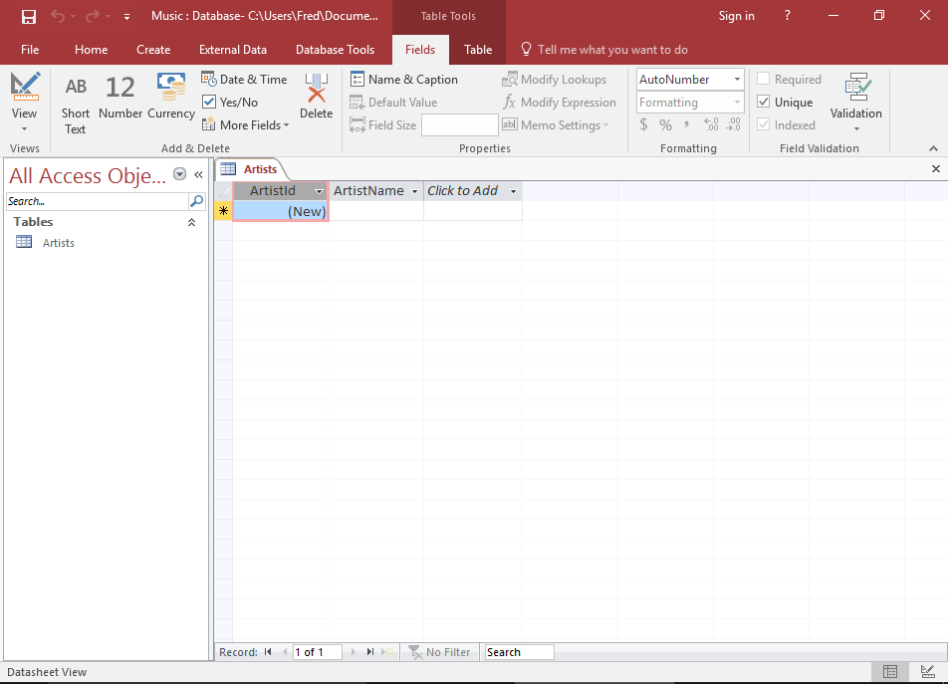

**Create a New Table**

1. **Select Table Option**

Ensuring the Create tab is selected on the Ribbon, click Table. This will add a blank table called Table1 to the database.

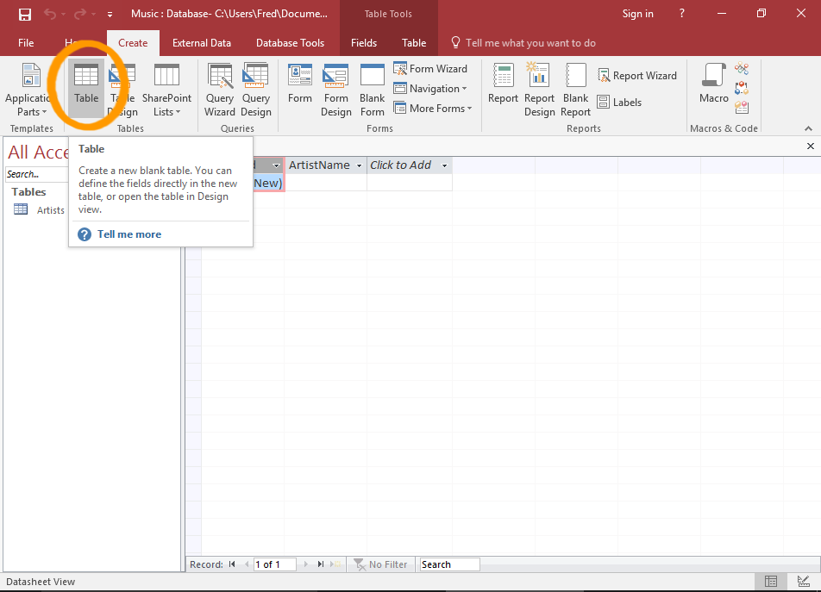

### Set up the Fields

Now add 4 fields and rename the first. Set them up as follows:

